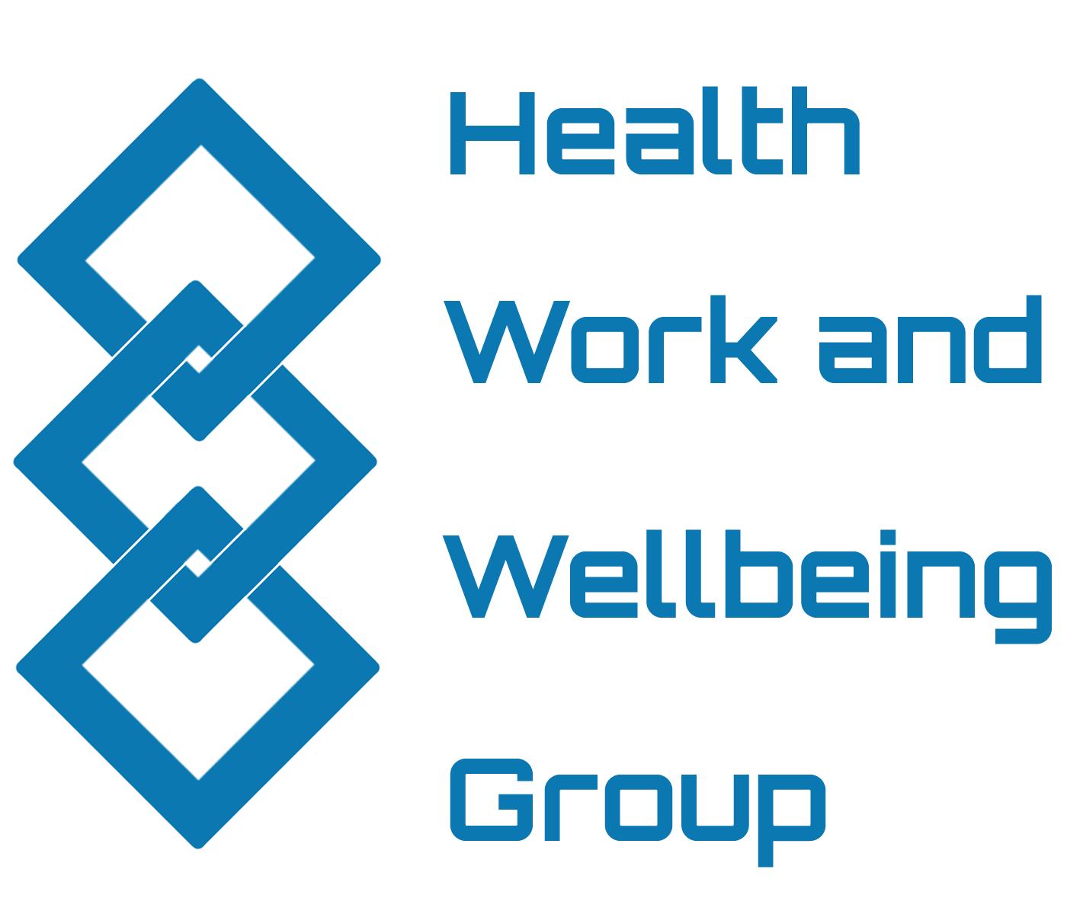
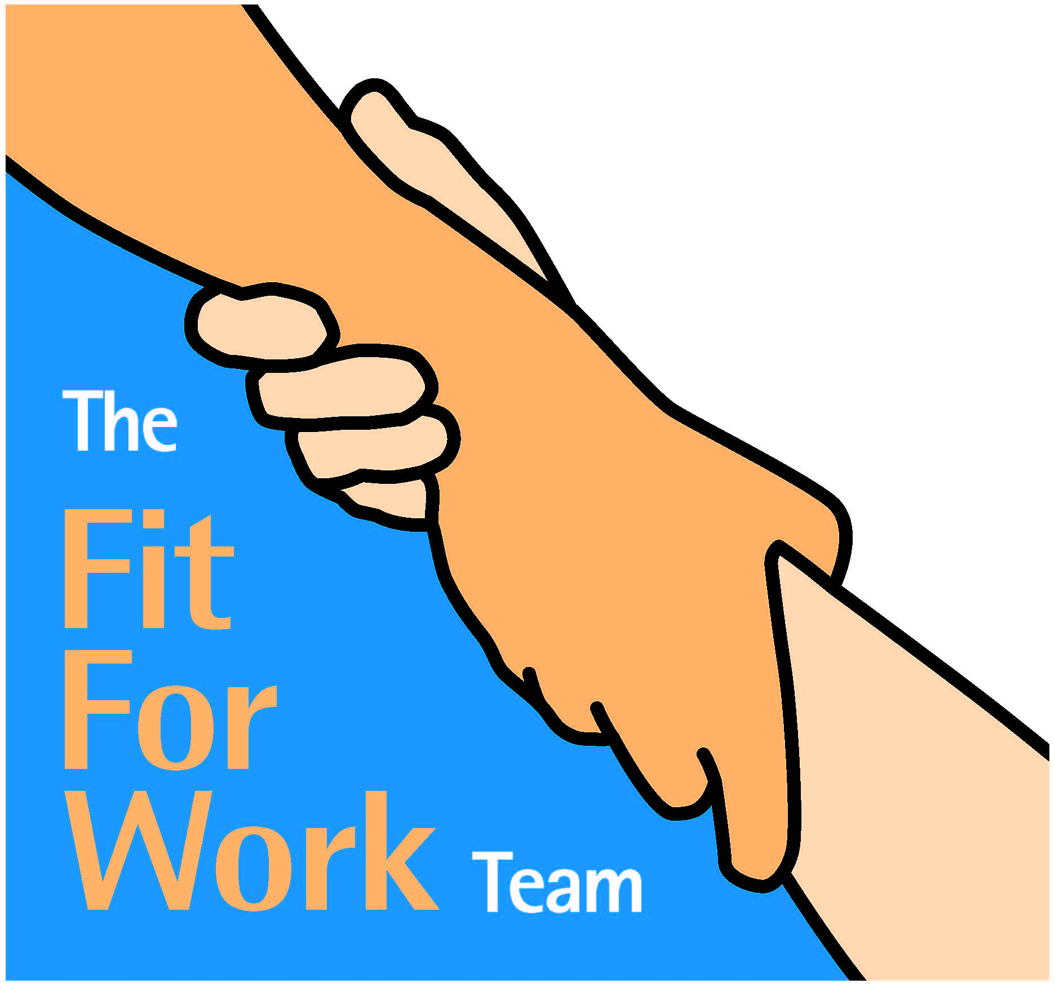
Nottinghamshire Health and Work Service

What is the Nottinghamshire Health and Work service?
The service helps people who have health conditions preventing them from moving closer to employment. We will help you to manage your condition, feel ready to work and help you get back to work more quickly

How can I access the service?
Ask your work coach or GP to refer you into the Health and Work service. You can print off a Referral Request form from our website and take it with you or simply ask to be referred

What happens next?
Once you have been referred to us we will call you and arrange an appointment with a Case Manager. Your case manager will work with you to understand the problems you may face in your return to work, and help you to solve them. We have access to a wide range of services as well as 1-2-1 support.

Our 5 promises to you are that we will:
1 Work with you to understand and solve problems that are keeping you out of work.
2 Be impartial.
3 Support you during difficult times when trying to get back to work.
4 Always work and advise with your best long term interests in mind.
5 Seek your permission before we discuss your case with others.

What do you have to do?
We would like you to agree to 5 principles that will help us to help you:
1 Talk to us openly and honestly about the problems keeping you out of work.
2 Allow us to talk to people or organisations that need to have a part in helping you back to work.
3 Keep an open mind about ways we can help. Success stories often start with people being doubtful!
4 Keep appointments and talk to your Case Manager if you can’t make it or if anything about your work or health changes.
5 Allow us to keep confidential paper and computer records about your case.
Need more information?
If you would like to ask us any questions please phone us on 0116 2851710 visit our website www.fitforworkteam.org
Need more information?
If you would like to ask us any questions please phone us on 0116 285 1710 or visit our website www.fitforworkteam.org

Need more information?
If you would like to ask us any questions please phone us on 0116 285 1710 or visit our website www.fitforworkteam.org

